

Updated 6/1999

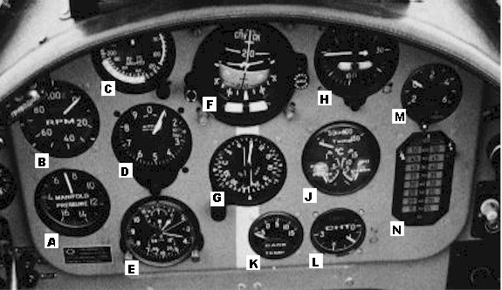

A
B
C
D
E
F
G
H
J
K
L
M
N
Manifold Pressure (in cms of Hg)
RPM in percent
Airspeed Indicator
Altimiter
Clock / Stop watch / Timer
Attitude Indicator
Gyro Compass / ADF / RMI
Turn & Bank / Rate of Climb Indicator
Oil Temp, Oil Pressure, Fuel Pressure
Carb. Inlet Temperature
Cylinder Head Temperature
Voltmeter / Ammeter
Digital Fuel Gauge

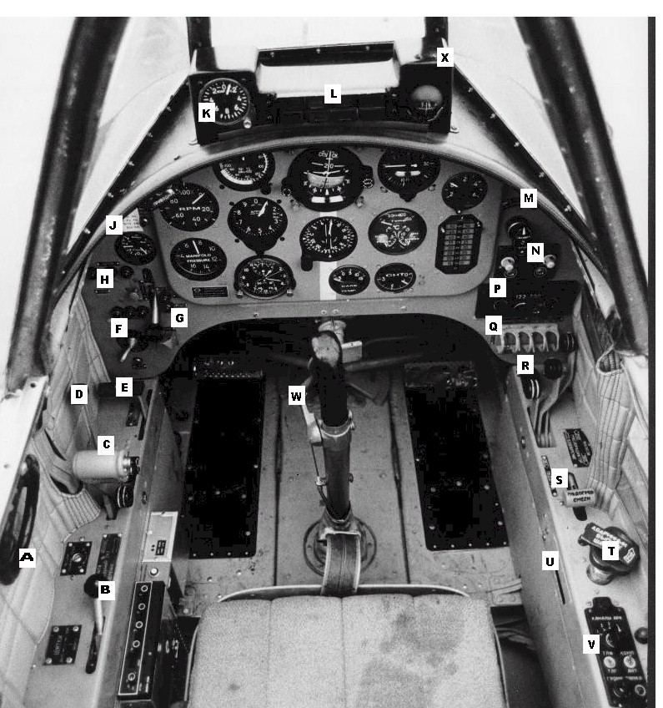
YAK 52 Cockpit
A
B
C
D
E
F
G
H
J

K
L
M
N
P
Q
R
S
T
U
V
W
X

Elevator Trim
Flaps
Throttle
Prop. Pitch
Fuel Cut-Off
Magnetos
Landing Gear
Landing Gear Lights
Air Pressure Gauge
Accelerometer
Annunciator Lights

Primer/Wobble pump
Audio Panel
Radio
Batt/Gen/Ign/Pitot Ht
Cooling Controls
Carb. Heat
Emergency Gear Extn.
Cabin Heat
ADF Control Panel
Wheel brakes
Compass

Aircraft Dimensions

Overall length 25 ft
Wingspan 30 ft
Height 9 ft
Wing area 157 sq ft
Dihedral 2 degrees
Wing incedance 2 degrees

Intercom/Audio Panel

The intercom unit enables communications between the two cockpits. It is not voice activated but rather uses the lower of the two buttons on the side of the throttle control. The intercom has two channels selected by the lower left switch on the control panel. Either may be used and there is no difference between them, they simply provide some redundancy.

Intercom Master Volume
Volume

Main/Sby ADF Audio

Radio

The 720 channel radio is operated from the control panel on the lower right section of the instrument panel. The frequency required is selected in the usual way, from two rotary knobs. The selected frequency appearing in the window between the two knobs. The other controls are a rotary volume control and the squelch control which may be set for high (down) or low (up) sensitivity. For transmission, a push to talk switch is provided on the upper part of the throttle control.

122.75
MHz
KHz

Volume
Squelch

Gyro compass

0°
360°
SOUTH
NORTH
LATTITUDE
SLAVE
FREE
ADJUST

The Gyro compass installed in the Yak 52 is a slaved gyro with latitude compensation. It may be operated in a slaved or free mode.
To operate the unit in FREE mode, set the SLAVE/FREE switch to FREE and adjust the heading indicator with the ADJUST switch. To more quickly set the heading, use the 0 deg. / 300 deg. switch to set the compass to those headings.
To use the Gyro in slaved mode, in which it will automatically align its self to an internal magnetic compass, set the switch to SLAVE (forward), set the North/south switch to NORTH (forward) for northern hemisphere and using the large tuning knob in the center of the panel, set your approximate latitude in the latitude window.
The unit will now automatically compensate for compass errors and the instrument face will indicate your exact magnetic heading.
The most usual way to operate the gyro-compass is with all four switches in the forward, or spring-loaded positions.

Radio compass

The radio compass installed in the Yak 52 allows the selection of 8 stations whose frequency is determined in the electronics box installed behind the seat of the rear cockpit. Eight channels may be selected from the cockpit. Select channels 1 to 4 by means of the large knob mounted at the forward end of the control panel. To select the second four channels, the switch mounted on the top left of the instrument panel coaming should be moved to the second position. The channel selector knob will now allow the selection of channels 5 to 8.

4
3
2
1

Voice
ADF

Ident
ANT

Volume
Test

The TEST switch causes the instrument pointer to rotate around the dial. The ADF/Antenna switch selects normal Radio compass operation (ADF) or audio only (Antenna) The Voice/Ident switch selects the Morse code ident from the NDB or its voice transmission.
Information on how to set the frequencies of the eight stations is to be found in the separate paper: YAK52 ADF programming”.

Master switch panel

Located immediately below the radio, the four switches control, from left to right:

1) Battery (UP = ON, DN = Ext power, CENTER = OFF)
- Generator
- Ignition (For starting)
- Pitot and clock heaters

In all cases, UP is ON, DOWN is OFF

Supplementary switches

The switches located at the forward edge of the right side Panel and below the master switch panel operate as follows (from left to right):

1) Oil dilution
2) Stall warning vane heater
3) Enable stall warning

The oil dilution switch dumps fuel into the oil supply for extreme cold weather starting and is operated momentarily.

Avionics/Instrument switches

The main electrical switch panel, located by the front pilots left elbow, controls the radios and instruments. Starting from the front and working rearwards, the switches control the following:

1) Gyro compass
2) Radio compass
3) Engine Instruments
4) Radio compass Inverter
5) Landing gear lights
6) Attitude indicator power
7) Intercom
8) Radio

(In all cases, ON is towards the left, OFF to the right)

Weights

Dry Weight 2205 lbs
Fuel weight 198 lbs
Oil weight 22 lbs
Parachute weight 33 lbs
Takeoff weight 2838 lbs

Performance

Maximum level airspeed 164 Kts
Range (10% reserve at 105 Kts) 280 NM
Stall speed, engine at idle,
Erect flight 60 Kts
Inverted flight 76 Kts
Flaps extended 55 Kts
Takeoff run (Standard Atmos.) 585 ft
Landing run " " 975 ft

Limitations

Never exceed speed VNE 230 Kts
Maximun airspeed at max Gs (+7/-5 G) 197 Kts
G limits +7/-5
Maximum gear extended speed (VLE) 110 Kts
Minimum speed Erect flight 71 Kts
Inverted flight 93 Kts
Maximum inverted flight time 2 mins

NOTE:

Allow three minutes of normal errect flight after each two
minutes of inverted flight to allow the oil to cool.

Ceiling 13000 ft
Minimum fuel qty for aerobatic flight 20 litres

Engine Data

Vendeneyev M14P Engine:

Cooling system air/fuel
Number of cylinders 9
Propeller reduction ratio 0.658
Compression ratio 10.6:1
Fuel type 91/155
Octane number >91
Carburetor type Pressure
Dry weight 471 lbs

Engine Limitations

Maximum time at max power:

Takeoff 5 mins
At max rpm 1 min
All other times No limit
Inverted flight 2 mins
Maximum allowable rpm 2950 (101%)
Minimum allowable rpm 700 (24%)
Time from idle to max rpm < 2 secs

Power settings

Rating | HP | RPM | % | Fuel Consumption | Blower Outlet Pressure (mmHg)
Take Off | 360 | 2900 | 99% | 285-315 grams/HP/hour | 125 - 15 (surplus)
Nominal I | 290 | 2400 | 82% | 280-310 | 95 -15 (surplus)
Nominal 2 | 240 | 2050 | 70% | 265-300 | 75 -15 (surplus)
Cruise 1 | .75 of N2 | 1860 | 64% | 210-230 | 735 mmHg +/-15 (absolute)
Cruise 2 | .6 of N2 | 1730 | 59% | 215-235 | 670 mmHg +/-15 (absolute)

Aerodynamic data

Engine torque 1215 ft lbs
Best climb angle (at 80 kts) 12 degrees
Glide angle (Gear & Flaps Up) 7:1 at 93 Kts
Engine/prop static thrust 1212 lbs
Roll rate 140 deg/sec

Aerobatics

The Yak 52 is permitted to perform all the maneuvers listed in the Aresti / FAI catalog with the exception of ( ?? tail slides. ??)

Emergency Procedures

Engine failure

If an engine failure occurs at takeoff before the first turn (after takeoff) is made:

- Establish the best glide speed (93 Kts) and trim to that
- speed.
- Retract the landing gear
- Operate fuel cut-off (Move rearwards)
- Switch off Mags, Battery and ignition.
- Open cockpit
- Land straight ahead if possible, otherwise, make shallow turns
- only.
- If the failure occurs after the first turn or in the pattern
- turn towards the runway and execute a normal landing.
- Should the engine stop whilst inverted:
- Half roll to erect flight
- Establish and trim to the best glide speed (93 Kts)
- Set the throttle to one third open
- Turn the mechanical fuel pump 45 degrees left
- Pump fuel pressure up to 0.1 -> 0.2 Kg/M

NOTE **

An engine restart from inverted flight will use at least
1200 ft of altitude!

Low Oil pressure

Check oil temperature. If increasing, land as soon as practicable otherwise attempt to cool the oil by reducing power, increasing airspeed and opening the cooling shutters.

Emergency landing in confined area

If an emergency landing must be performed in a confined area, minimize the landing roll by landing with gear UP.

Low fuel pressure

Turn the mechanical fuel pump 45 left and pump to provide fuel pressure. Land to investigate as soon as possible.

Engine roughness

Reduce power, establish and trim for best glide speed (93 Kts). If the roughness stops, carefully increase power so as to establish level flight.

If the roughness continues, increase rpm to 72% to clear the spark plugs.

If the roughness still persists, experiment with the power setting in order to find a combination of manifold pressure and rpm that minimizes the vibration and land as soon as possible.

Propeller overspeed

If the maximum permitted rpm is exceeded during takeoff, reduce rpm by means of the propeller control and continue the takeoff.

In-flight fire

- Activate the fuel cut-off (Move rearwards)
- Establish and trim for the best glide speed (95 Kts)
- Side-slip if necessary, to help blow the flames away from the cockpit
- Perform an emergency landing
- If the fire continues unabated, bail out immediately.
- NOTE ** DO NOT INCREASE SPEED. It can considerably intensify the fire.

Emergency landing gear extension

If it is not possible to extend the landing gear in the usual
way, perform an emergency extension as follows:

- Check emergency air pressure is at least 10 Kg/sM
- Set landing gear lever to neutral in both cockpits
- Wait as long as fuel allows for air to exhaust
- Reduce speed to minimum (71 Kts)
- Open emergency gear release valve on the right side of the cockpit
- Check for green "Gear Down" light
- Close the emergency gear release valve only after completing the flight and shutting down the engine
- DO NOT ATTEMPT TO RAISE THE GEAR USING THE EMERGENCY SYSTEM

Landing with flaps up

Landing without flaps is little different to a normal landing.
It is only necessary to allow a little extra speed (90 Kts) and to bear in mind that the landing distance will be consequently increased

Radio failure

- Check headphone plugs are secure
- Check "YKB" switch is ON
- Check volume control is at maximum
- Check correct frequency is selected

Bailing out of the aircraft

NOTE ** Leaving the aircraft at speeds greater than 110 Kts is most hazardous as is attempting to bail out at less than 500 ft altitude.

The most reliable way to leave the aircraft is to roll inverted and exit at a low airspeed. From this attitude:

- Bunch up you body as small as possible
- Release the harness and any back-up straps
- Push the stick forward and fall from the aircraft

If you have to bail out from upright flight:

- Release the seat belt
- Lift the parachute out of the seat pan
- Stand up in the seat
- Roll out of the aircraft, head down in a somersault position
- If both seats are occupied, the front seat occupant should
- leave the aircraft first.

Landing with failed engine

With gear and flaps retracted, the aircraft glides at a ratio of 7:1. With gear down, the ratio is 5:1. From these figures, the gliding distance may be determined.

A speed of 88 Knots will achieve the greatest distance in no wind but in a turn, 93 Knots will provide slightly less height loss.

Gliding turns are best made at a 45 degree angle of bank.

Checklists

Preflight

If the aircraft has not been flown in a week or more, the following extra procedures must be followed:

- Remove the lowest two spark plugs and clean.
- Remove the drain plugs in the three lowest inlet manifold
- pipes and allow any collected oil to drain.

Then:

- Inspect the ground around the prop. for loose items, gravel etc.
- Check Propeller for nicks
- Check cowl flaps (louvers) for correct operation
- Ensure oil radiator cover is removed
- Check landing gear struts. Should be about 4 or 5 inches extended
- Check fuselage for damage
- Check ground for oil leaks
- Check cowl latches are secure
- Check main landing gear security - tires - latch & indicator
- Check flaps
- Drain fuel system
- Check rear fuselage for loose rivets and antennas
- Check control surfaces for freedom of movement
- Check cockpits for loose items
- Check canopy for cleanliness and cracks
- Check ailerons for freedom of movement
- Remove Pitot cover & check static ports
- Check stall warning system (If fitted)
- Visually check fuel level
- Visually check oil level.
- MAX LEVEL:
- Normal flight 16 litres
- Aerobatic flight 10 litres
- MINIMUM level: 8 litres

Before Entering the cockpit

Check the following items in the FRONT cockpit:

- Ensure no loose objects in the cockpit
- Check seat for damage
- Check condition of seat belts
- Check MAG switches to '0'
- Check starter button is covered by guard
- Check all switches OFF
- Check landing gear selector in DOWN position and latch engaged
- Set brakes ON
- Set main air supply to ON position (Fully counter clockwise)

In the REAR cockpit:

- Ignition switch set to "1st cockpit" (UP)
- MAGS set to "1+2" (Both)
- Gear control in neutral and locked
- Flap control in neutral and locked
- Instrument failure switches OFF (DOWN)
- rake override switch OFF
- Parachute removed
- Straps secured and tied
- Canopy locked in closed position

After Entering the cockpit

- Adjust rudder pedals for reach
- Fasten and check the seatbelts
- Connect the headset cord
- Ensure canopy slides freely and can be locked
- Check flight controls for freedom of movement
- Check elevator trim for freedom of movement
- Check clock reading. Wind and set if necessary

Cold Start

- Double check air supply is ON (Or you will have no brakes!)
- Set cooling controls fully forward
- Set prop to MAX RPM (Full forward)
- Set throttle to 1/3 open position
- Set fuel valve to OPEN (full forward)
- Set CARB HEAT to HOT (Full rearward position) if temperature is below freezing, otherwise fully forward
- Turn MAGS OFF ('0')
- Ensure that master switch is OFF (center position) and ignition switch is OFF (Down)
- Ground crew must pull propeller through at least 12 blades
- Turn on the Master switch and the Engine switch
- Turn the primer to the "SYSTEM" (left) position pump slowly until fuel pressure is indicated
- Turn the primer to the right, "CYLINDER" position and pump 5 strokes. Leave the pump in the OUT position.
- Switch ON:
- Master switch
- Generator
- Ignition
- Engine Instruments
- Landing Gear lights
- Lift the guard flap and press the starter button
- As the engine turns, turn the MAG switch to "1+2"
- When the engine fires, push the primer in to further prime the cylinders. Lock it when the engine is running
- Increase power slowly to 40 % rpm
- Check engine instruments for correct indications, especially oil pressure

Warm Start

Same as cold start except:

- Set throttle further open, (About 1/2 way)
- Prime the cylinders no more than 2 strokes

Warming up

Allow the engine to warm up until all temperature indications are in the Yellow or Green ranges of the instruments. If the outside air temperature is low, you may close the cooling louvers to speed up the warming process.

Continue to monitor all engine instruments during the warm up period for signs of trouble

While waiting for the engine to reach its proper temperature, turn on the required systems and Avionics and test as necessary.

Taxi Check

- Brakes CHECK
- Turn & Bank, Gyro CHECK
- Flaps operation CHECK
- Altimeter SET

To turn the aircraft on the ground, apply rudder pedal in the direction you wish to turn and squeeze the brake lever. This action diverts air pressure to the side towards which you have applied the rudder and causes the aircraft to turn in that direction. To stop the turn, apply opposite rudder and brakes.

Engine Run-up

- Brake SET
- Oil Temp. Min. 40 deg.
- Oil Pressure 4 - 6 Kg/Cm
- CHT Min 120 deg.
- Fuel Pressure 0.0 - 0.5 Kg/Cm
- Throttle 70 % RPM
- Magnetos Max 3% drop CHECK
- Propeller Cycle 3 times CHECK
- Carb Heat Set as required
- Throttle 60 % RPM
- Elevator trim 1 Pilot - 45 degrees tailwards, 2 Pilots - Neutral
- Flaps UP

!!! ENSURE COOLING CONTROLS (LOUVRES AND OIL COOLER FLAP) ARE FULLY FORWARD AND FIRMLY LOCKED !!!

Take off

- On the runway, allow the aircraft to roll forward so the nose wheel centers.
- Apply full power
- Lift the nose wheel as soon as possible
- Allow the aircraft to fly off and accelerate in ground effect to a climb speed of 90 Knots.
- Retract the landing gear and climb away at 90 Knots. Check for gear up indication
- When aproaching pattern altitude, reduce power to 80% RPM and 800 mm Hg manifold pressure
- Ensure CHT does not exceed maximum limits during the climb

Cruise

The following settings produce a reasonable compromise between speed and economy. They should produce about 120 Kts and 15 gallons per hour.

- Propeller 70 %
- Manifold pressure (120 Kts) 600 mm Hg
- Engine Instruments CHECK

IN COLD WEATHER, exercise propeller every 30 mins

Aerobatics

- Propeller 82 %
- Manifold Pressure AS REQ'D
- Engine Instruments CHECK
- Fuel Quantity ( > 40 Litres) CHECK
- Cockpits (No loose Items) CHECK
- Airframe (Flaps UP) CHECK)

Pattern

The Russian manual contains more than 10 pages of advice on flying the pattern which does not correspond to the way a pattern is flown in the USA

The pages have not, therefore, been translated.

Refer to the Airmans Information Manual section 220 for advice on this subject

Descent

Leave the propeller set to about 60 to 70 % RPM
Reduce power as requires being careful to maintain a CHT of at least 120 deg. C

Before Landing

- Gear Down (Below 110 Kts) and CHECK
- Flaps Down (Below 93 Kts) - usually applied on short final
- Speed 90 Kts
- Propeller MAX RPM (Russian manual says just before turning finals)
- Flare 83 Knots
- Touch Down 65 Knots

After Landing

When clear of the runway,

- Flaps UP
- Pitot Ht. OFF

Engine Shut down

- Radio OFF
- Circuit Breakers
- Radio OFF
- Alternator OFF
- Nav. Instr. OFF
- Propeller MAX
- Throttle 30 % RPM
- CHT 140 - 150
- Throttle 70 % for 10 secs
- Throttle 27 %
- Mags OFF
- Circuit Breakers
- Intercom OFF
- Landing gear OFF
- Engine Instr. OFF
- Ignition OFF
- Battery and Master Switch OFF
- Compressed Air valve CLOSED
- Engine Cowl louvers CLOSED
- Oil Cooler Flap CLOSED
- Second Cockpit
- Magnetos OFF
- Landing Gear DOWN
- Compressed air system DRAIN

